Guest parking Booking via City Spidey App

**Dear Residents, We are now making the guest parking online for you all . AOA will be monitoring this and after the trail of 30 days we will amend the procedure if required.**

**Go to Bookings -> Click Make a Booking and fill the following form:-**

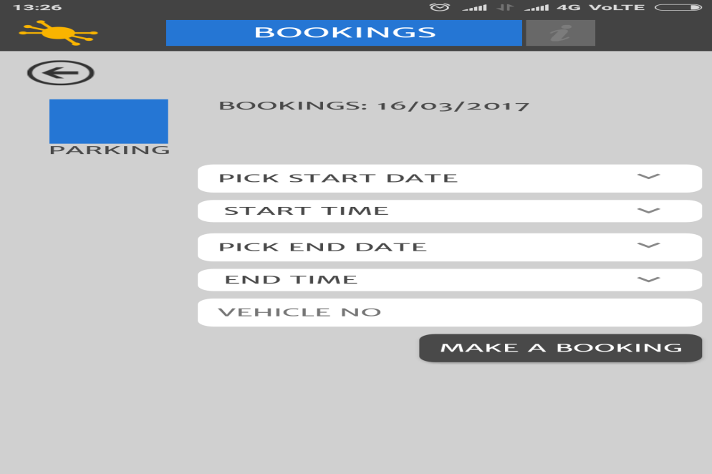

**Booking Request can be seen in My Booking in pending state:-**

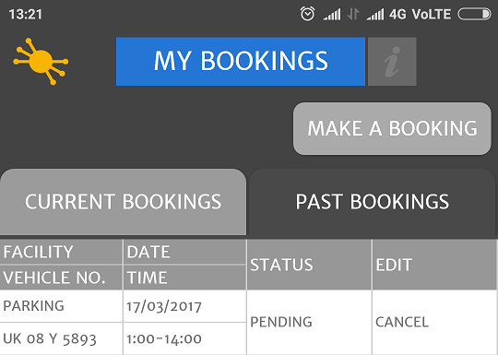

**Admin receive the request in pending state to which he approves/cancel:-**

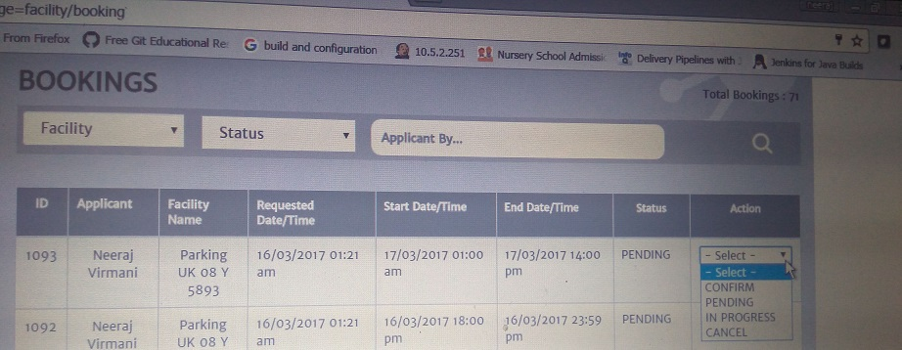

**Once admin confirms Resident see the status in APP-> My Bookings:-**

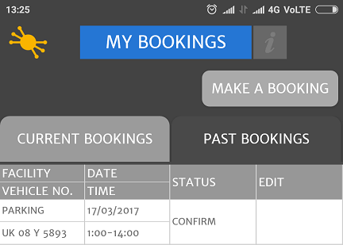

**The above screen can be shown on gate for entering the society, Car number and time of entry n exit is mentioned on the app itself.**